My experiment results from Question Survey
Link to my experiment survey questions https://docs.google.com/forms/d/1hgMyN7lnYs6p9ZBeTyFol4c4CvkTtbQ4e1goKESWh1k/prefill
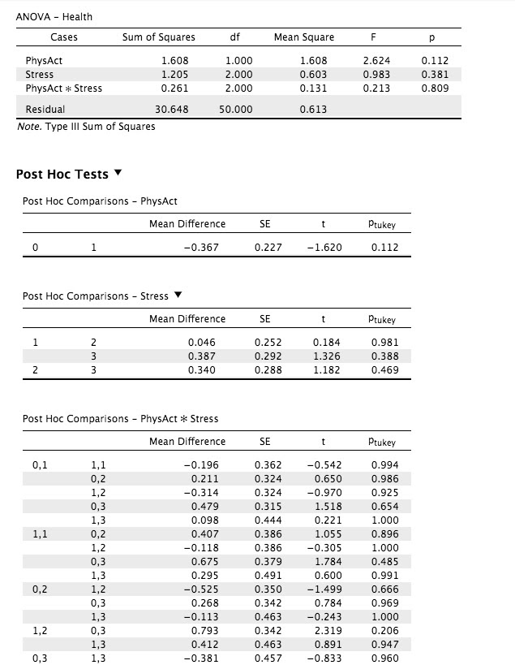

There was not a significant main effect of state of being physically active on perception of health F(1,50) = 2.62, p=0.112.
There was not a significant main effect of stress level on perception of health F(2,50) =0.93, p=0.381.
There was not a significant interaction effect between state of being physically active and level of stress on the perception of health F(2,50) =0.213, p=0.809.
Results/Post Hoc test
Since nothing is significant, you shouldn't run any post hoc tests.﻿﻿﻿

